Kenya

## Political Stability Estimate Data

The data set shows the political stability estimate of the country each year.

## # A tibble: 19 x 5  
## country iso3c date stability stabilityCategory4   
## <chr> <chr> <dbl> <dbl> <chr>   
## 1 Kenya KEN 1996 -0.654 moderately unstable  
## 2 Kenya KEN 1998 -0.905 moderately unstable  
## 3 Kenya KEN 2000 -1.07 highly unstable   
## 4 Kenya KEN 2002 -1.19 highly unstable   
## 5 Kenya KEN 2003 -1.26 highly unstable   
## 6 Kenya KEN 2004 -1.09 highly unstable   
## 7 Kenya KEN 2005 -1.25 highly unstable   
## 8 Kenya KEN 2006 -1.13 highly unstable   
## 9 Kenya KEN 2007 -1.30 highly unstable   
## 10 Kenya KEN 2008 -1.39 highly unstable   
## 11 Kenya KEN 2009 -1.43 highly unstable   
## 12 Kenya KEN 2010 -1.17 highly unstable   
## 13 Kenya KEN 2011 -1.24 highly unstable   
## 14 Kenya KEN 2012 -1.32 highly unstable   
## 15 Kenya KEN 2013 -1.17 highly unstable   
## 16 Kenya KEN 2014 -1.28 highly unstable   
## 17 Kenya KEN 2015 -1.24 highly unstable   
## 18 Kenya KEN 2016 -1.35 highly unstable   
## 19 Kenya KEN 2017 -1.08 highly unstable

## Political Stability Estimate Plot

The plot shows the trends of stabilization and destabilization for the each country.

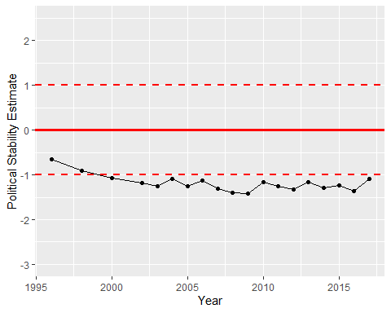

Political Stability Trend